An Act of Remembrance
at Home

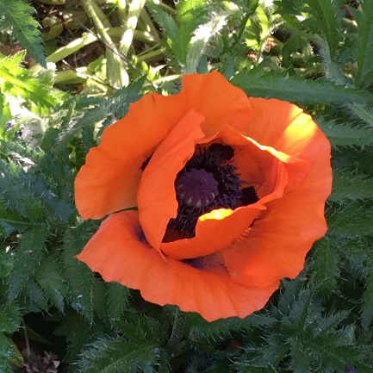

Bible Reading Psalm 23
The Lord is my shepherd;
therefore can I lack nothing.
He makes me lie down in green pastures
and leads me beside still waters.
He shall refresh my soul
and guide me in the paths of righteousness for his name’s sake.
Though I walk through the valley of the shadow of death,
I will fear no evil;
for you are with me;
your rod and your staff, they comfort me.
you spread a table before me
in the presence of those who trouble me;
you have anointed my head with oil
and my cup shall be full.
Surely goodness and loving mercy shall follow me all the days of my life,
and I will dwell in the house of the Lord for ever.

A candle may be lit, or a wreath or poppy placed on a windowsill or doorstep.

They shall grow not old,
as we that are left grow old;
age shall not weary them,
nor the years condemn.
At the going down of the sun
and in the morning,
we will remember them.
We will remember them.
Two minutes’ silence may be observed.
Prayer
O God of truth and justice,
we hold before you those people
who have died in active service.
As we honour their courage
and cherish their memory,
may we put our faith in your future;
for you are the source of
life, peace and hope,
now and for ever. Amen.

The Lord’s Prayer
Our Father, who art in heaven,
hallowed be thy name;
thy kingdom come;
thy will be done;
on earth as it is in heaven.
Give us this day our daily bread.
And forgive us our trespasses,
as we forgive those who trespass against us.
And lead us not into temptation;
but deliver us from evil.
For thine is the kingdom,
the power and the glory, for ever and ever. Amen.

Bible Reading Psalm 46: 1-3
God is our refuge and strength,
a very present help in trouble.
Therefore we will not fear,
though the earth should change,
though the mountains shake in the heart of the sea;
though its waters roar and foam,
though the mountains tremble with its tumult. Amen.

